What to do after obtaining a crystallization hit from the screen?
- Immediately reset the condition that yielded the crystals using commercial screens. Recommended to set up two wells (400 uL each) with two drops of the DNA. That is why it is always good to have extra DNA when you prepare your sample for screening.

- Remake the condition that produce crystal by hand. Suggested amount, 10 mL. Follow the protocol:
Reagent | Stock concentration | Desired concentration | V, mL
Reagent 1
Reagent 2
Reagent 3
Water

Example: Remaking Natrix-1: 0.01 M Magnesium chloride hexahydrate, 0.05 M MES monohydrate pH 5.6, 1.8 M Lithium sulfate monohydrate
Reagent | Stock concentration | Desired concentration | V
0.01 M Magnesium chloride hexahydrate | 4 M | 0.01 M | 25 uL
0.05 M MES monohydrate pH 5.6 | 1 M | 0.05 M | 500 uL
1.8 M Lithium sulfate monohydrate | 2.5 M | 1.8 M | 7.2 mL
Water | - | - | 2.275 mL

Important: when you assemble the condition, you need to filter it before proceeding.
Set up at least 10 wells/two drops per well with this hand made condition.

- Ideally you would want to wait to see if your conditions grow crystals.
  - If you get crystals everywhere – proceed to optimization step (4).
  - If you only get crystals from the commercial screen but not from the handmade screen – recheck your calculations, recheck your stocks (and maybe make some new ones) and remake the condition. Reset the crystals and hopefully they will grow this time. If a few attempts do not produce crystals you have two choices – set up more crystals with Mosquito or ask Liliya to order a 100 mL bottle of the condition you need and set crystals by hand. This would typically cost $180.
  - If you do not get crystals at all – give it more time. And if you still do not see crystals – try to set up with Mosquito a few rows to hopefully get the crystals back. It is possible that the crystals will regrow with Mosquito but not when you set the tray by hand.
- Optimization. At this point you would need to set a grid screen to improve the quality of your crystals. Start by planning the screen. The most important thing to optimize is your precipitant – PEG, MPD, Li₂SO₄. Next thing to optimize are salts – KCl, NaCl, etc. Finally, for GQs we never optimize buffers. This may not be the case for i-motif for which buffer or pH would need to be optimized. Start by setting up a very coarse screen where the condition of interest is in the middle of the screen. Here is the example of optimizing Natrix-1. We will optimize Li₂SO₄ horizontally. Each column will contain the same amount of Li₂SO_{4.}

1.2 Li₂SO₄ | 1.4 Li₂SO₄ | 1.6 Li₂SO₄ | 1.8 Li₂SO₄ | 2.0 Li₂SO₄ | 2.2 Li₂SO₄

At the same time we will optimize the salt vertically, which is 10 mM MgCl₂ in this case. Here we will keep the same amount of MgCl₂ across each row.

5 mM MgCl₂
10 mM MgCl₂
15 mM MgCl₂
20 mM MgCl₂

- Now that you have done the planning, you can go to this webpage which will help you set up this screen:
https://hamptonresearch.com/make-tray.php

Detailed instructions on how to use the page and set up new tray can be found here:
https://hamptonresearch.com/make-tray-instructions.php

Just like before, to fill this page correctly you would need to know the concentration of your stock solutions.

You will get two tables out:
The first one describes the content of each well
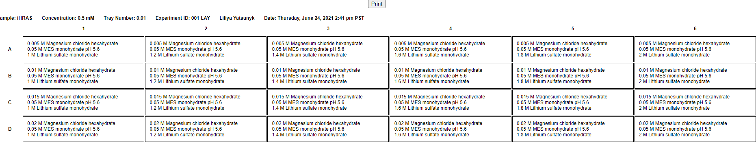
And the second one tells you how to prepare each well:
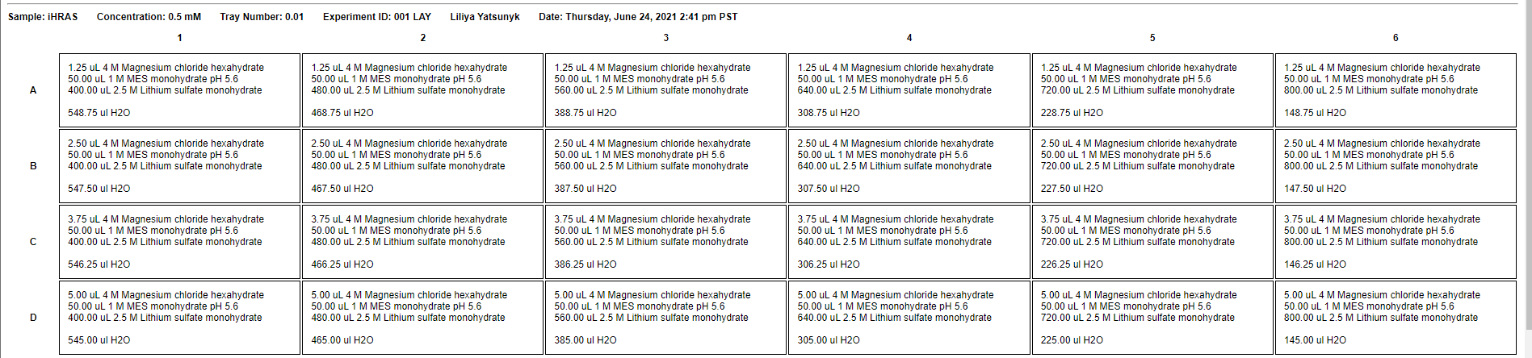
It will also tell you how much of each reagent you need so you can prepare appropriately.
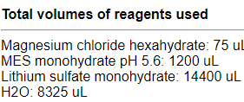

There is no limit to what you can try. Just keep good notes and mark the progress.
- Set up crystal factory: once you get the crystals that you like – make large amount of that condition – 10 mL or even 50 mL and set up multiple trays with it – hopefully the trays will produce sufficient number of high-quality crystals.
- Good luck!

