**The Supervisor’s responsibility is to check the student’s time for accuracy and to approve by noon on Tuesday.**

**Employee Dashboard:** Your dashboard is updated to include time entry, leave reporting, and any time approval options you may have depending on your job responsibilities.

**APPROVE A TIMESHEET**

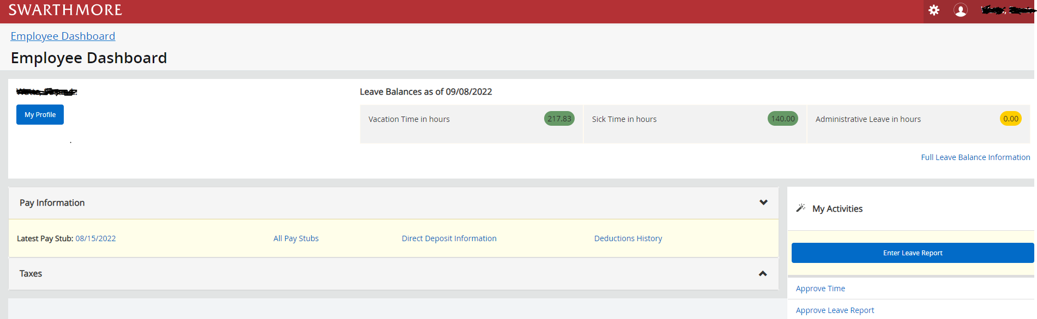

To approve the student timesheet, click on Approve time.

**Select the Pay Period for the Timesheet Approval**

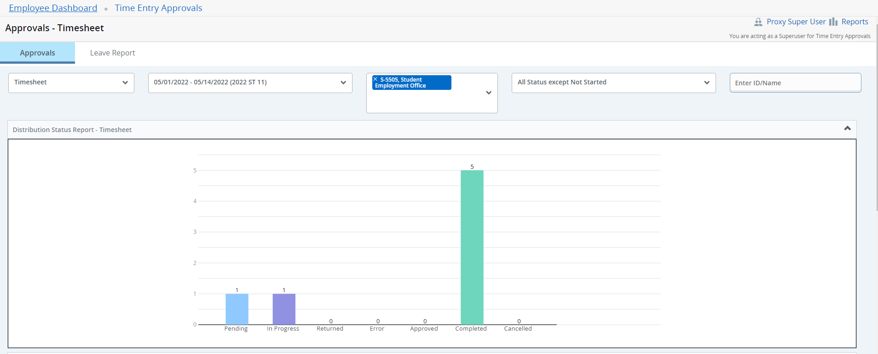

*You can double-click on the ‘Pending’, ‘In progress’, or ‘Completed’ bar on the graph to filter.*

Click on the student’s name to view a detailed summary of the timesheet.

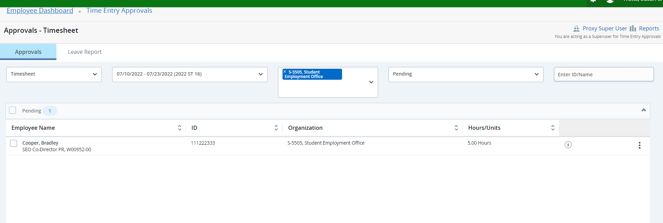

The student’s submitted timesheet will provide the hours they worked over the two-week work period.

Review for accuracy

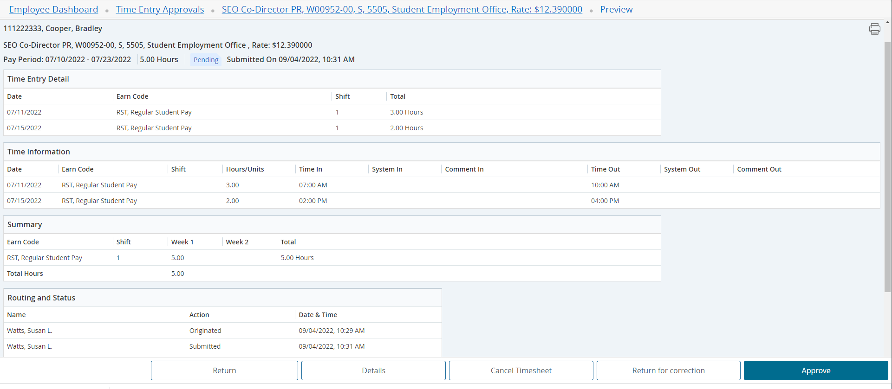

**Return** will take you back to the previous screen.

**Details** shows you the weeky detail veiw as the student entered the time.

This is where the Approver can make corrections to the Time Record if necessary.

**Return for Correction** will return the Time Record to the student for correction.

**Approve** will approve the Time Record.

**Comments** can be made to explain to the student the reason for the return.



*Once approved, Timesheet can not be returned for corrections.*

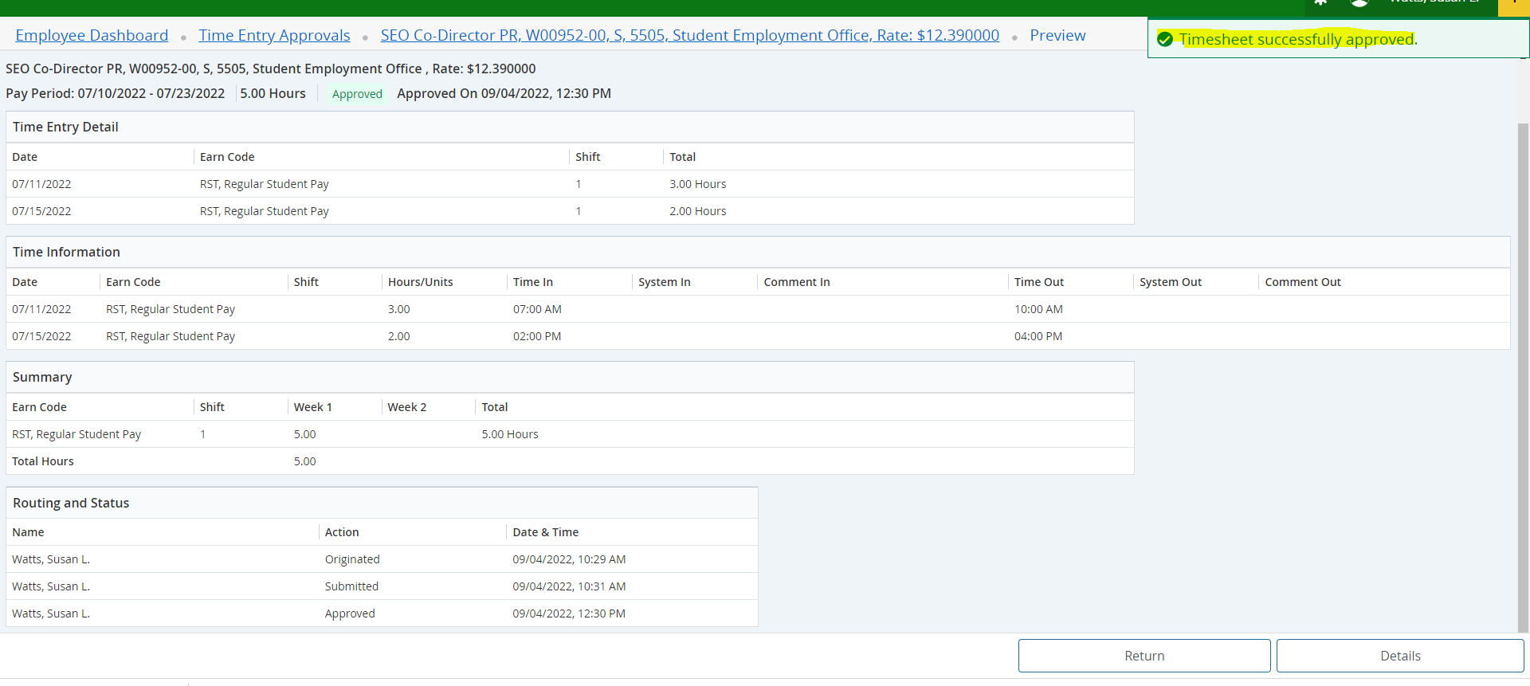

The **Return** will return the approver to the previous page.

**FAQ’s**

**Status of timesheets:**

**In Progress –** Still in the student’s queue. The timesheet still needs to be submitted for approval.Deadline for students to submit timesheet

Is 10:am on Monday.

**Pending –** Submitted for approval by the student, in the superviosr’s queue.

**Completed –** Approved by the supervisor. Deadline to approve timesheet is noon on Tuesdy.

**Not Started –** Student has not opened timesheet.

**All supervisors should have a proxy in their absence.**

**The student should be entering their time after each shift.**

**No student should be working until they have completed all their paperwork and have been hired.**

**If you have any questions, please call or email:**

**Karen Phillips**

**Email:** [**kphilli1@swarthmore.edu**](mailto:kphilli1@swarthmore.edu)

**Phone: 610 328 8395**

**Susan Watts**

**Email:** [**swatts1@swarthmore.edu**](mailto:swatts1@swarthmore.edu)

Phone: **610 328 8677**

**Jodie Koenigs**

**Email:** [**jkoenig1@swarthmore.edu**](mailto:jkoenig1@swarthmore.edu)

Phone: **610 328 8677**