Accommodate Faculty User Instructions

Swarthmore College

Student Disability Services (SDS)

Student Disability Services (SDS) has implemented a new accommodation management platform called Accommodate. Your Accommodate portal will house important information about your students’ accommodations. Please follow the step-by-step instructions below to access and navigate your Accommodate portal.

### Log-in

[Accommodate (Faculty Interface)](https://swarthmore-accommodate.symplicity.com/sso/faculty/login?) and select “Faculty”

### Home Screen

After you log-in you will arrive in the “Home” section.

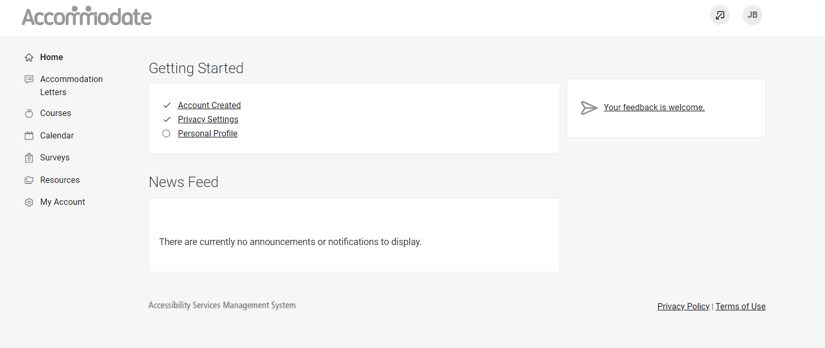

### Accommodation Letters

To view a student’s accommodation letter select “Accommodation Letters.” Select the letter that you wish to view. If your signature is requested, “Requested” will appear in a black rectangle next to the letter. Once a letter is signed, the text will indicate “signed.”

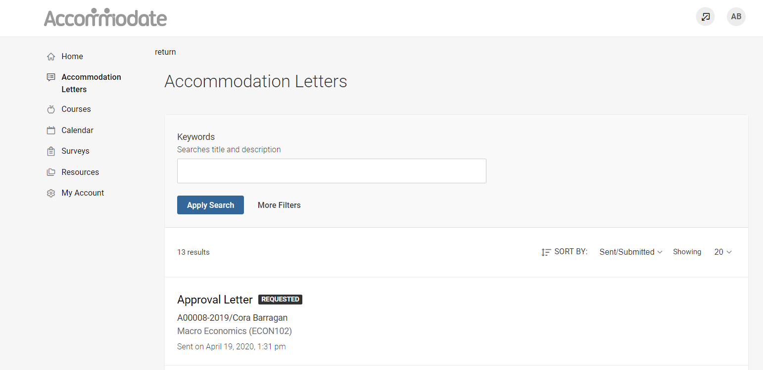

Once the letter is open, you have the option to print or generate a PDF of the accommodation letter. If your signature is requested, please complete the form as indicated. To return to the full list, select “Return to List (Accommodation Letter)”

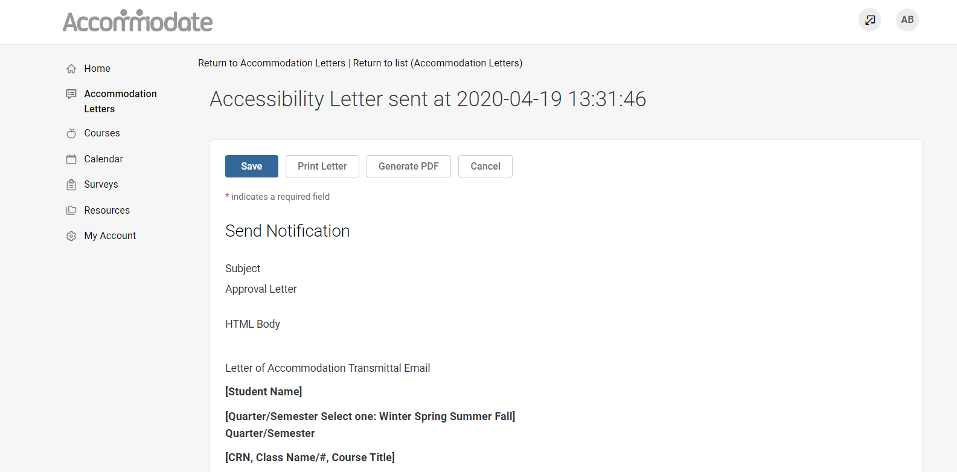

### Courses

To view course details, enrolled students, room bookings, exams, or course notes, select “Courses.” Select the course you wish to view.

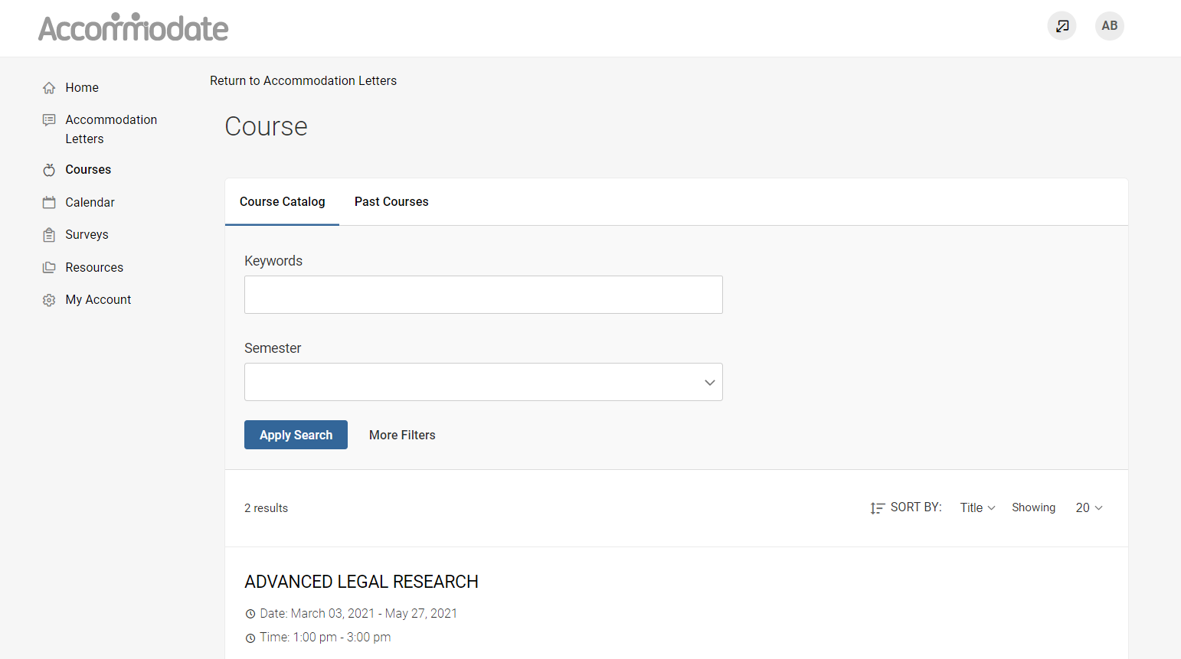

### Enrolled Students

To view enrolled students with accommodations, select “Enrolled Students” and then select “More Filters.” Select “Yes” Under Approved Accommodations for this Course to view only students who are approved for accommodations in this course.

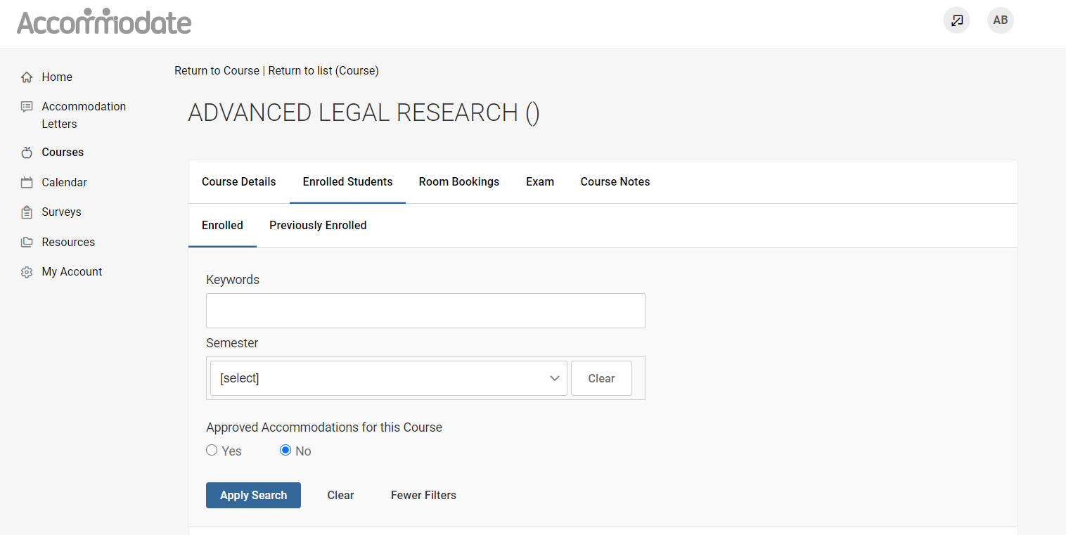

### Exams

Faculty who are unable to administer accommodated exams will use Accommodate to manage exam appointments. Additional information/training will be available in the coming weeks.

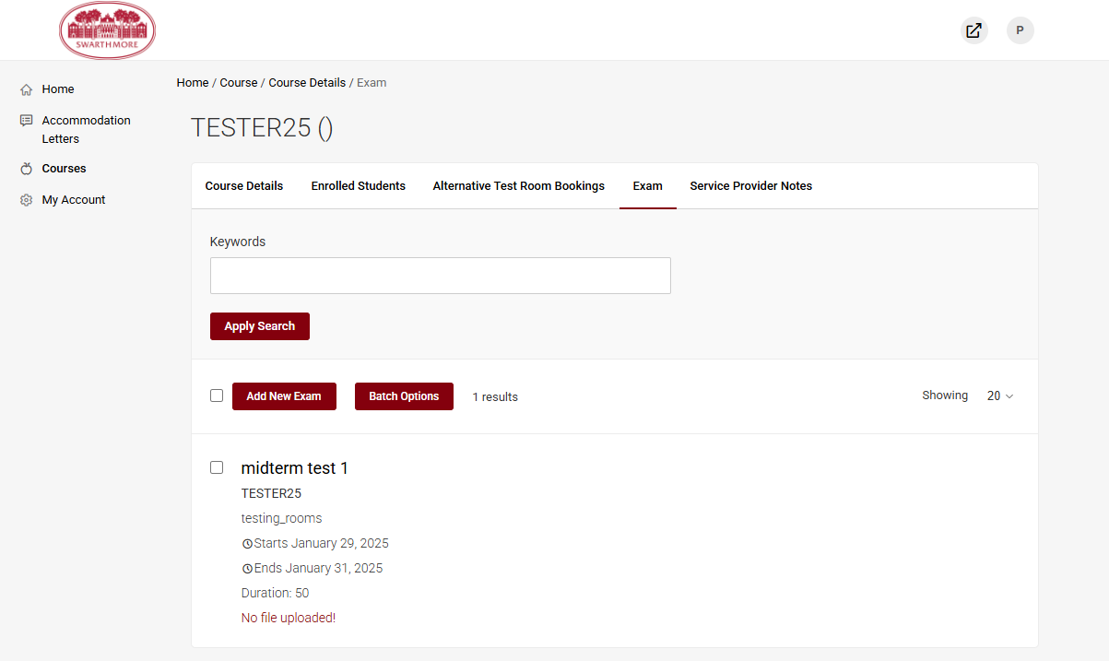

### Alternative Test Room Bookings

To view students who have requested exam accommodations, select “Alternative Test Room Bookings” > “Approved.” Additional information/training will be available in the coming weeks.

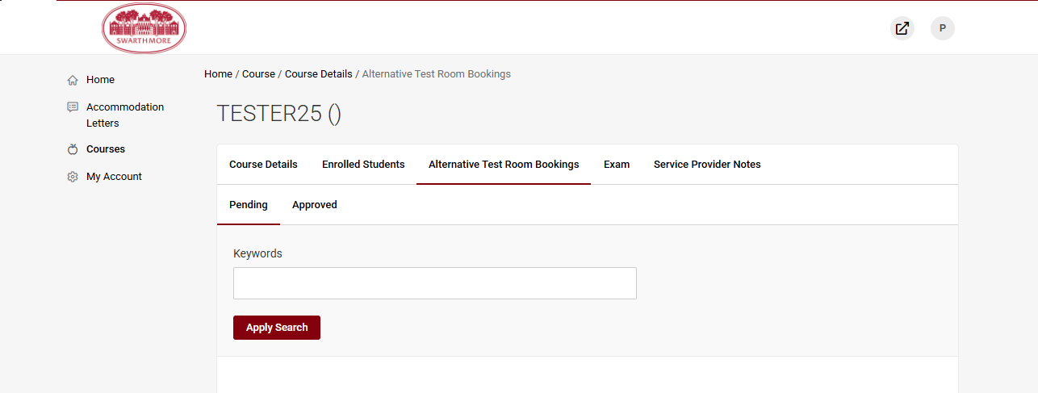

### 

### Notes

To view notes that have been uploaded for your course or to add notes for your course, select “Notes” > “Add New”

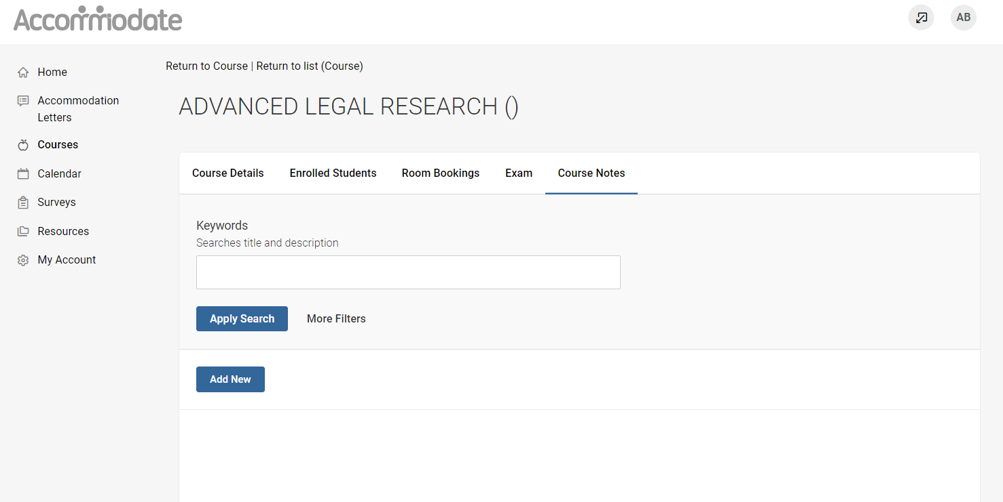

### Resources

To view resources uploaded by SDS, select “Resources” > “Resource Library”

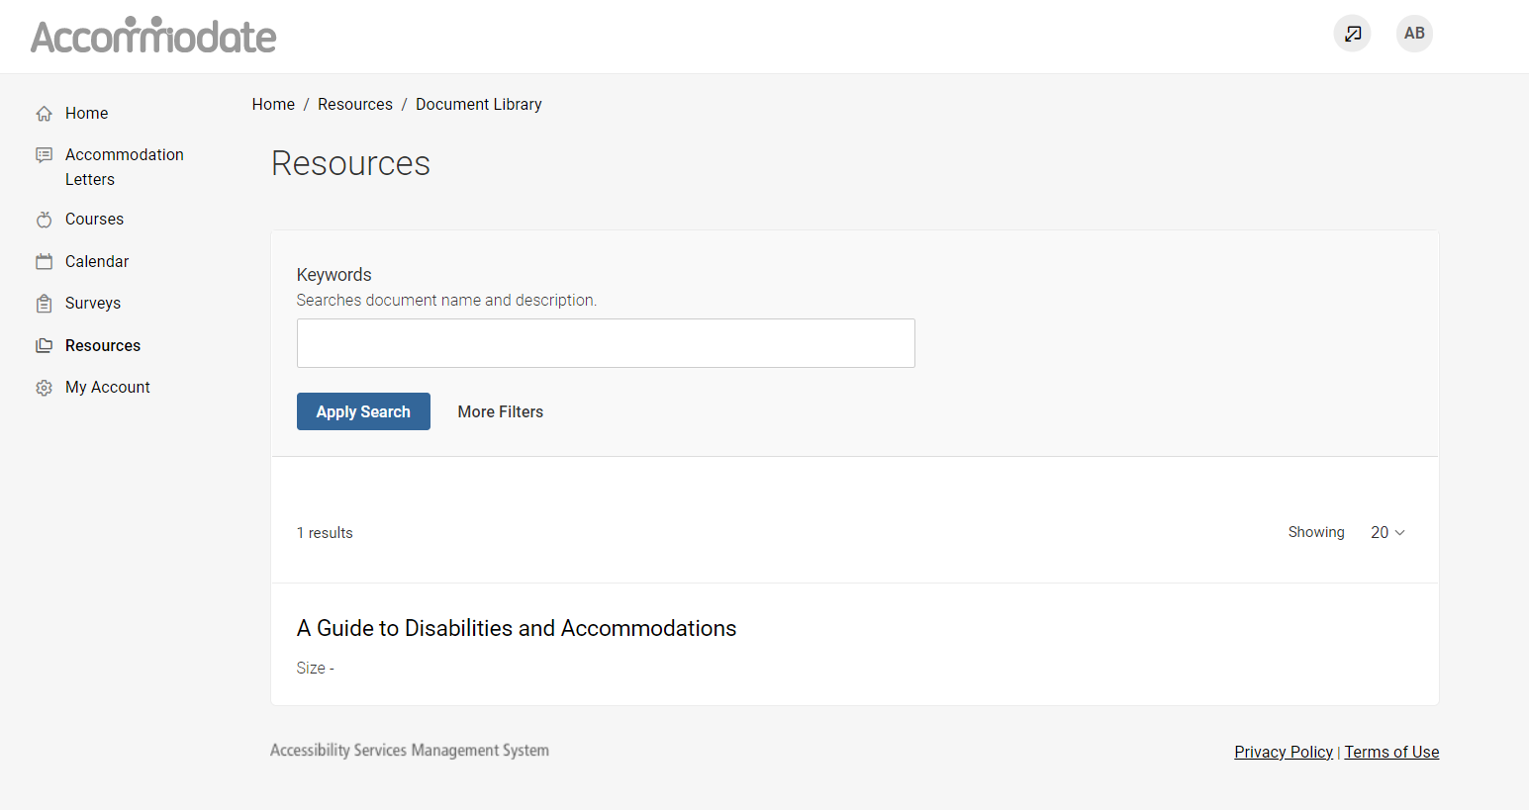

### Personal Profile

By selecting “Personal Profile” on the homepage you can view and edit your account details

